# To install ESB Toolkit 2.0

## Assumption

Assumptions are made that everything is installed on the one server.  
The following applications are installed in there default locations

* Office 2007
* vs2008
* sql 2008
* biztalk 2009
* WSS 3.0

UDDI is not installed.  
The script will not install any of the samples as the sample bindings use a different strong name key. To install the samples, the binding files require to modified with the strong name key that is generated to build the portal.

# Directory setup

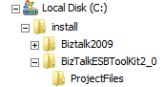

Biztalk2009 contains the contents of the biztalk 2009 ISO (for the UDDI install).  
BizTalkESBToolKit2_0 contains all the msi required to install ESB 2.0 toolkit plus an unzip.ps1 script.  
BizTalkESBToolKit2_0\projectFiles contains files that which replace source files to build on x86 platform.

# Installing

**\*\*\*This is not a silent install\*\*\***

Modify the ConfigFiles\run.config

<OrderToInstall>  
 <add key="1" value="Biztalk2009ESBToolKit20" />   
</OrderToInstall>

Execute c:\install\installBizTalkESBToolkit2_0.bat

Configuring UDDI dialog will appear select custom configuration. Make sure that require **SSL for publication to this UDDI Services site** is not selected

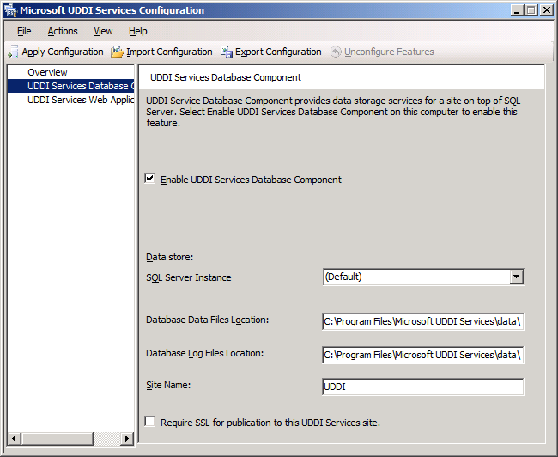

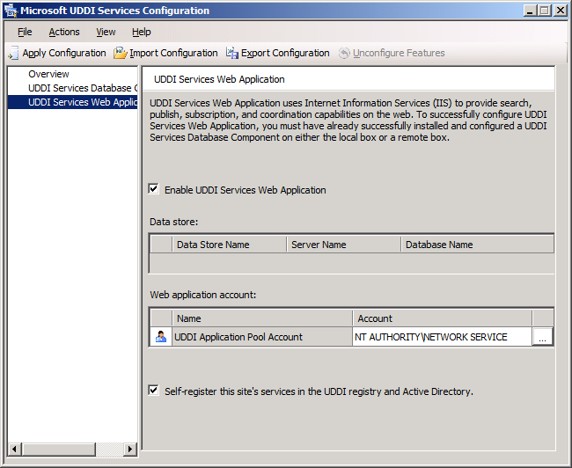

Apply configuration and close configuration window when finished

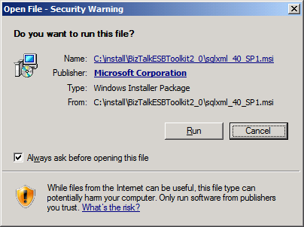  
Click Run

ESB Configuration Tool

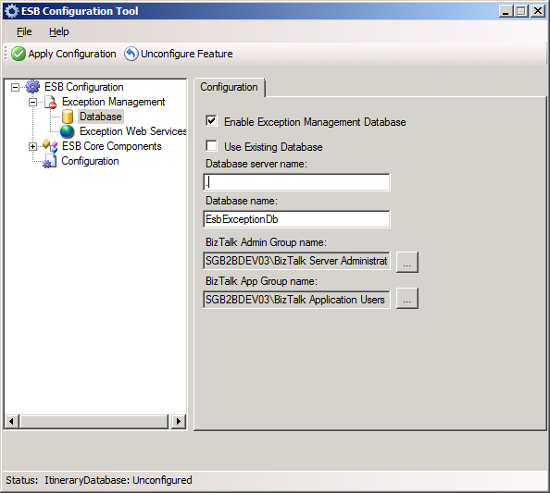

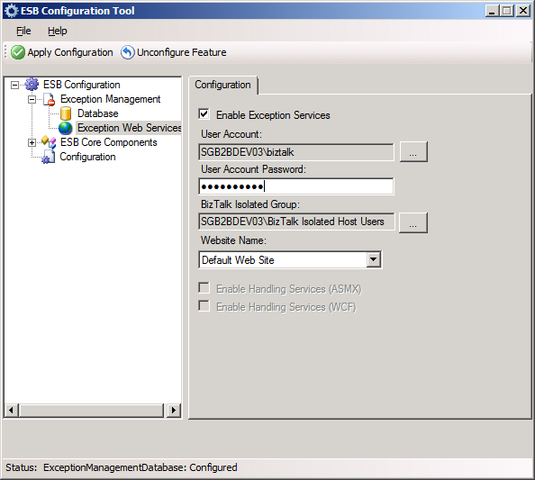

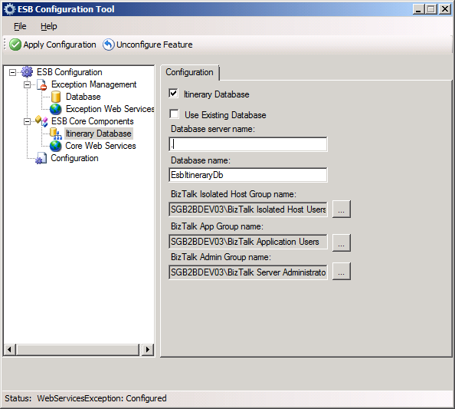

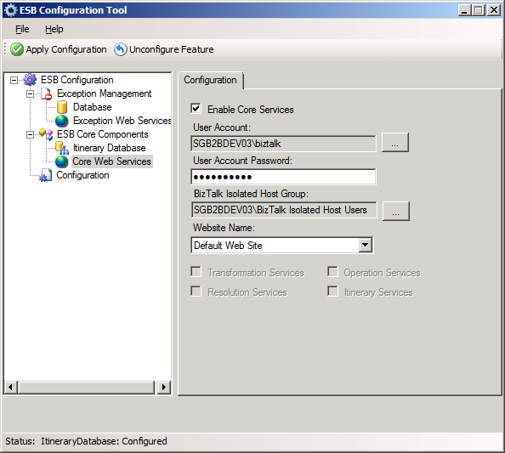

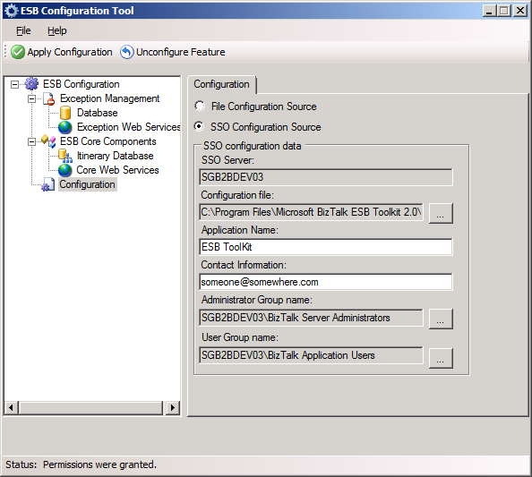

Microsoft.Practices.ESB.UDDIPublisher.exe select **n**  
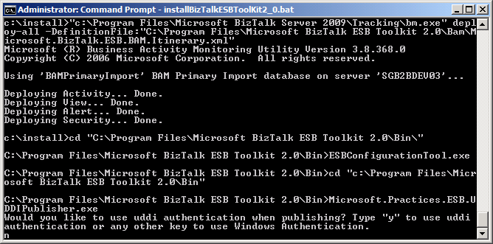

Dynamic Resolution Install enter username and password for current user  
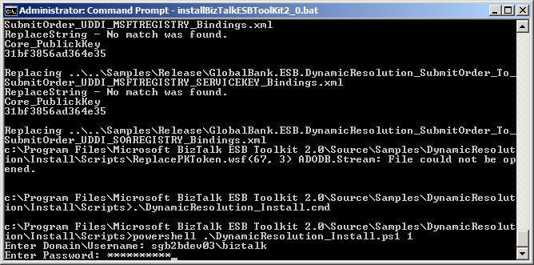

Biztalk ESB UDDI Publishing Service  
